Day 6 – 26 Mar 2024

Spring Framework or Adv Spring Framework

40 hours training

Spring boot, Spring reactive modules, spring web client, spring with hibernate.

Spring transaction management, spring security etc.

<https://start.spring.io/>

springboot-with-jpa-data

starter --🡪 Web

starer 🡪 thymeleaf view

starter 🡪 jdbc for database connection

starter -🡪 jpa provide orm features

dependencies -🡪 mysql connector

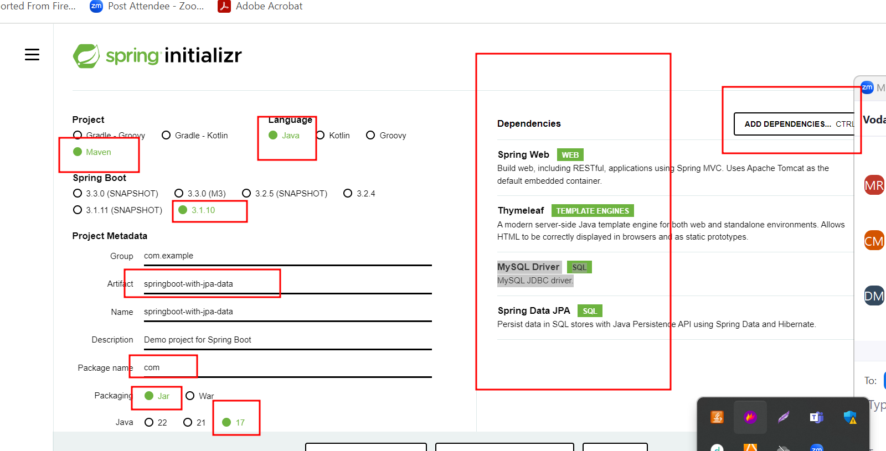

<https://docs.spring.io/spring-boot/docs/current/reference/html/application-properties.html>

application.properties file contains all resources details.

Like server port number

Security

Database related file. : dispathcher-servlet.xml

Spring with database

1. Data source
2. JdbcTemplate
3. ORM Hibernate or JPA
4. Spring JPA Data: it is a spring module which provide abstract dao layer.

CrudRepository : core interface or super interface

JPARepository : sub interface provide JPA implementation

This interface base upon java 8.

By default @controller, @service, @repository annotation are disable.

To enable we need to use @CcomponentScan in spring framework but in boot we can use basePackage scan attribute part spring boot application annotation.

Product

Pid 🡪 Pk

PName 🡪

Price

Product to Orders : one to many relationship

Orders

Oid PK auto – increment

Pid FK pid as fk

DateAndTime current system date and time.

Web Service : Giving the Service for web application when both application running using different technologies.

Amazon : Spring boot :

Payment 🡪 paypal Spring boot

Paytm Python with Django

Gpay Express with Node JS

Phonepay Asp.net

Net banking

Credit card php

Etc

Java (req)

Java XML/JSON python

HDFC SBI

Python (res)

XML : eXtensible markup language

JSON : JavaScript Object Notation

Customer c = new Customer();

c.setId(100);

c.setName(“Steven”);

c.setAge(21);

XML format of Customer object is

<Customer>

<Id>100</Id>

<Name>Steven</Name>

<Age>21</Age>

</Customer>

JSON format

{“cid”:100,”cname”:”Steven”,”age”:21}

Web Service

1. SOAP Base Web Service : Simple Object Access Protocol

SOAP web service base upon SOA (Service Oriented Architecture).

In SOAP web service we can consume and produce the data only the format xml with SOAP Structure.

1. Rest full web service : in Rest full web service we can expose our resources like servlet, jsp or spring controller(mvn or spring boot) as web service in any format base upon client requirements.

In Restful web service we can consume or produce the data in any format like xml, json, plain text, html or media type etc.

Spring MVC with View as JSP

Spring boot with View as Thymeleaf

Python with Django 🡪 view as Django template

Express JS with Jade as View

We need to make our normal controller as rest controller. When our controller is rest controller the view can be

Java, python, php, angular, react js or any rest client etc.

Rest full web Service : Representational State Transfer

It is a concept. The implementation of Rest API

1. Jax_RS using jersey tools.
2. Spring boot

Creating Simple Rest API using Spring boot

We need to create project using spring initializer with web starter.

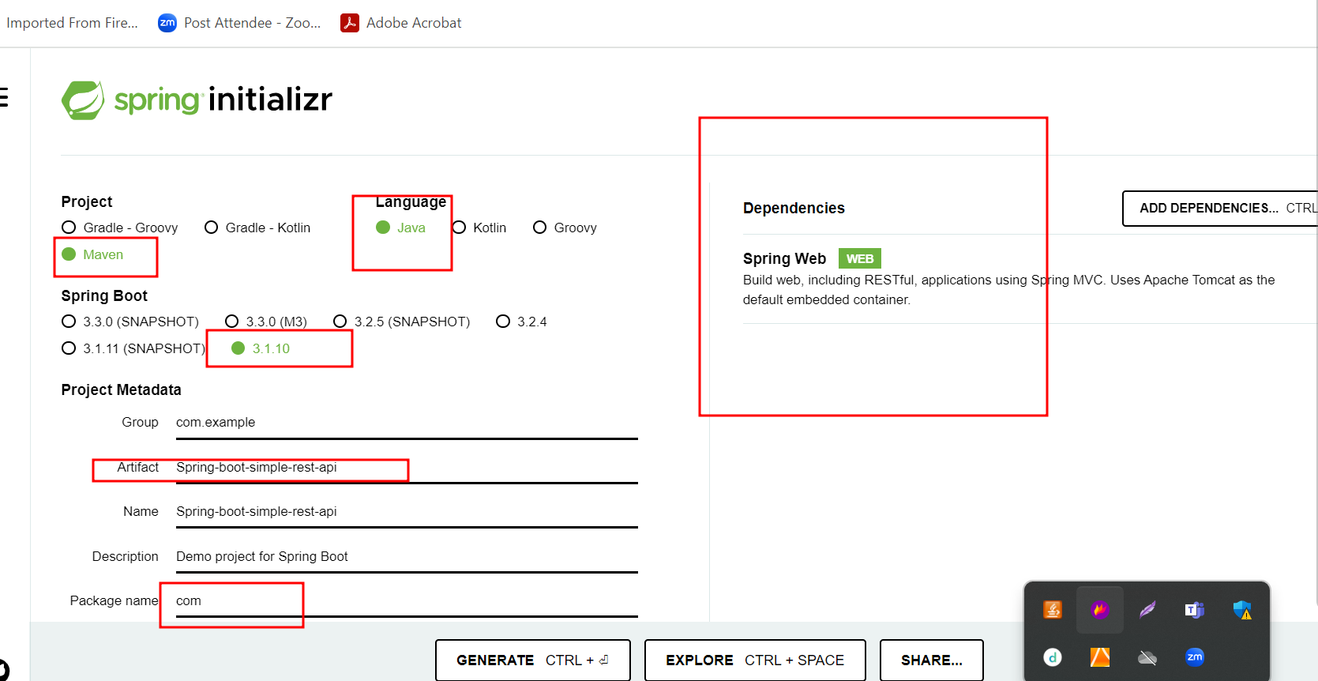

Get Methods : it is use to get the Resource like Employee, Login, Customer, Orders, Product etc.

1. Retrieve data in string format
2. Retrieve data in format can be plain text, html, xml etc
3. Retrieve user defined object in json format / XML format.

Using Get method rest client can pass the data using

1. Query param technique
   1. URL?key1=value1
   2. URL?key1=value1&key2=value2

By default html form with method as get internally use query param technique

1. Path param technique
   1. URL/value1
   2. URL/value1/value2/value3

Select query with where clause

Get method we can test with browser.

But remaining method like post, put, patch, delete we can’t test using browser.

We need rest client plugin

Post man client

Arch Client

Etc

Post Method : create resources , create employee record, product, order, account etc.

Insert query

Put as well Patch method: both method is use to update existing entity resources.

If we want to update partial object then we need to use patch.

If we want to update full object then we need to use put method.

Employee 🡪 Id,Name,Salary

Update salary using id then use patch method

Update name,salary using id then use put method.

Update query

Delete method : This method we use to delete the resources

In delete we use path param